Considering a referral for a cochlear implant?

You may be a suitable candidate for a cochlear implant because….
- You need to use subtitles because you cannot hear the TV anymore.
- You are no longer able to use the telephone for conversations.
- You unable to understand everyday conversation with people.

Your most recent hearing test is shown below. If you have 2 s and 2 s within the green box you could be a suitable candidate for a cochlear implant.
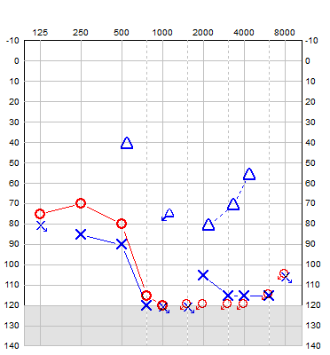
A cochlear implant is a prosthetic device that uses electrical stimulation to provide sound to patients with severe to profound hearing loss who gain little or no benefit from conventional hearing aids. It is made up of two parts: the sound processor which looks like a hearing and is worn behind the ear, and the internal part which is surgically implanted behind the ear.
A cochlear implant does not give you back normal hearing. Everyone is different and some people get more benefit from their cochlear implant than others. What you are likely to hear depends on your hearing history and will be discussed in detail with you during the assessment.

If you would like to be referred for a cochlear implant assessment, please return to the hearing aid aftercare clinic and speak to the audiologist.

Name: xxxxxxxx | Hospital number: xxxxxxxxx
https://www.southtees.nhs.uk/services/north-east-regional-cochlear-implant-programme-nercip

