
Loading Reports into Practice Navigator

- Close out of Practice Navigator
- Ensure that the PN Report file(s) have been saved on to your PC
- Log into Report Builder as an administrator (if you do not have an icon for ReportPN on your desktop it can also be accessed from Start/Programs/Practice Navigator/ReportPN)
- Click on the ‘New Report’ button at the top of the screen
- Select ‘Load from File’ from the ‘File’ menu on the toolbar
- Browse to the location of the reports, select the report and click the ‘Open’ button.
- The report should now be displayed on your screen
- Select ‘Save as’ from the File menu on the toolbar
- Select a folder from the ‘Save in’ drop down list at the top of the screen (this will be folder that the report will be displayed in the Reports Menu on the toolbar within Practice Navigator).
- Give the new report a name and click ‘Save’.
- Once the report has been saved, select ‘Close’ from the ‘File’ menu on the toolbar to return to the report explorer screen
- If you wish to view the reports in Practice Navigator they must be activated.

Activating Reports

- Close Practice Navigator and log into Report PN.
- Click on the folder that you saved the new report in on the left side of the screen. All the reports that are saved in the folder will be displayed on the right.
- Select the report that you wish to activate, right click on it and select ‘Report settings for PN’.
- Place a tick in ‘Show Report in Practice Navigator’.
- Place a tick against each security group that you would like to have access to this report (Typically Administrator, Audiologist and Clerical).
- Select the appropriate option from the Report Category list, Report, Letter or Questionnaire. If you wish to view this report from the Report menu in Practice Navigator select ‘Report’.
- If you wish to be able to run this report directly from a screen within Practice Navigator, select the appropriate screen from the bottom section of the screen. The list of screens available will change depending on which folder the report has been saved in to.
- Once all the settings have been adjusted, click ‘OK’
- Close out of Report PN and log back into the Practice Navigator, the new report will now be available.

Note: Other users will not be able to see the new report until they close out of Practice Navigator and log on again.

The ‘Report settings for PN’ should look something like the image below.

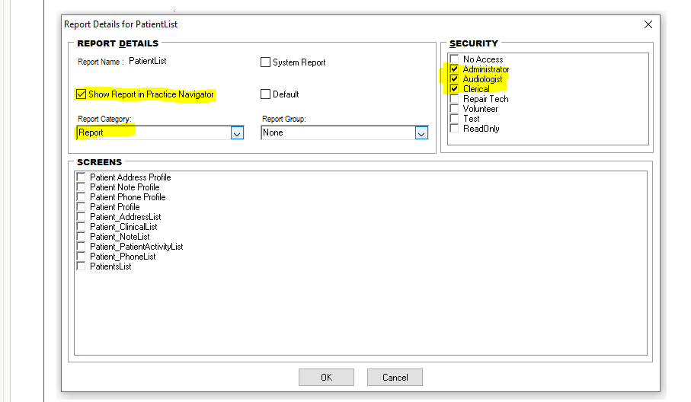

Considerations/limitations as follows:

- Report shows all audiograms rather than just the most recent audiogram. Therefore a patient will now appear multiple times on the report if they had multiple audiograms in the data period.

- The search fields are on 2 tabs now (one for date, the other for age/hospital). They can be used together though.

- Noah Session Date is in the report; so you can check that the results are in the range that you have filtered on.

- The dates are sometimes in different formats (some are date/time format and others just date format). I think the standard is date/time, but it’s just date is if the patient has been imported, or a date has been manually entered in the audiogram module. This means when searching you need to enter an extra day. For example if you enter 01/04/2020 it will interpret that as the date/time: 01/04/2020 00:00:00 (midnight). This means that searching ‘from 01/04/2020 to 01/04/2020’ would not find any records. Therefore, if you wanted to find audiograms added on 01/04/2020 you would need to search ‘from 01/04/2020 to 02/04/2020’.
o Sometimes it might include records from the next day that have been saved without the timestamp (eg just saved as 02/04/2020), but if so you will just have to remove them in Excel).

- The age is the patient’s age when running the report, rather than when the test as performed.

- The report is in Noah Session ID order, although this will not always be in Date order. Synchronisation allocates session IDs to laptops to use, so they are not used chronologically. Also audiograms can be added when patients are imported. Best to sort in Excel if you need in order.

