What is a Cochlear Implant?

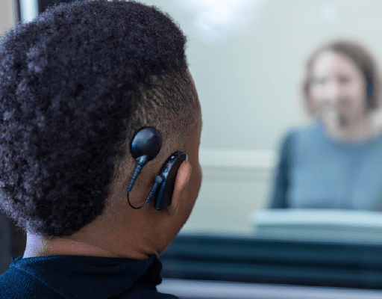 | This leaflet is about how a Cochlear Implant works and why it might help you.
 | You have a Severe to Profound hearing loss. This means you have a lot of damage to your hearing and hearing aids may not always help you to hear.
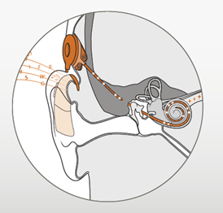 | Cochlear Implants work differently to hearing aids. They change sound to electrical messages. This means sounds are easier to hear.
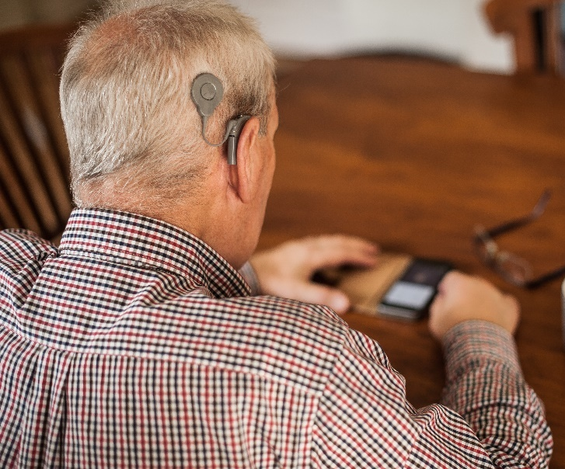 | A Cochlear Implant has a microphone that goes behind your ear. This looks a lot like a hearing aid. There is also a round magnet that goes on the side of your head.
 | A small part of the implant is put inside your ear during an ear operation. The operation is routine, and you can usually go home the same day or the next day.
 | The Cochlear implant can be put on and taken off easily, even if you have long hair. You can do this yourself, or others can help you.
A special waterproof cover keeps the Cochlear Implant dry in the swimming pool.
It is safe to play most sports with a Cochlear Implant.
 | It can take a few months to get used to the sound of a Cochlear Implant. Voices will sound more natural the more you wear the implant.
 | To find out if you are suitable you need to meet a Cochlear Implant Audiologist. They will ask you questions and do some tests. For example, they will ask you to listen to words and tell them what you hear.
 | You will meet someone who uses a Cochlear Implant so you can ask them questions and find out more.
 | A Cochlear Implant may not be right for you. The Cochlear Implant Audiologist will talk to you about how it might help.
It is your choice if you want a Cochlear Implant.
You can take as long as you want to think about it and decide.
Going to meet a Cochlear Implant Audiologist does not mean you are agreeing to have a Cochlear Implant.
If a Cochlear Implant is not right for you, hearing aids will still help you to hear.
Your Hearing Aid Audiologist can help you with your hearing aids.
 | This website has more information about Cochlear Implants: https://www.heartogether.org.uk/hearing-technology/cochlear-implants
There are 23 Cochlear Implant departments around the country. A list of local Cochlear Implant services can be found here:
https://www.bcig.org.uk/type/contact-centre/

