Dear <NAME>
I am contacting you on behalf of the British Academy of Audiology (BAA) to inform you about their annual conference which is taking place on the 18th and 19th November 2021 at the Manchester Central Convention Complex.
I was wondering if you would consider circulating the below information to your networks / uploading to your website? If you would like any additional information, please let me know. Thank you!
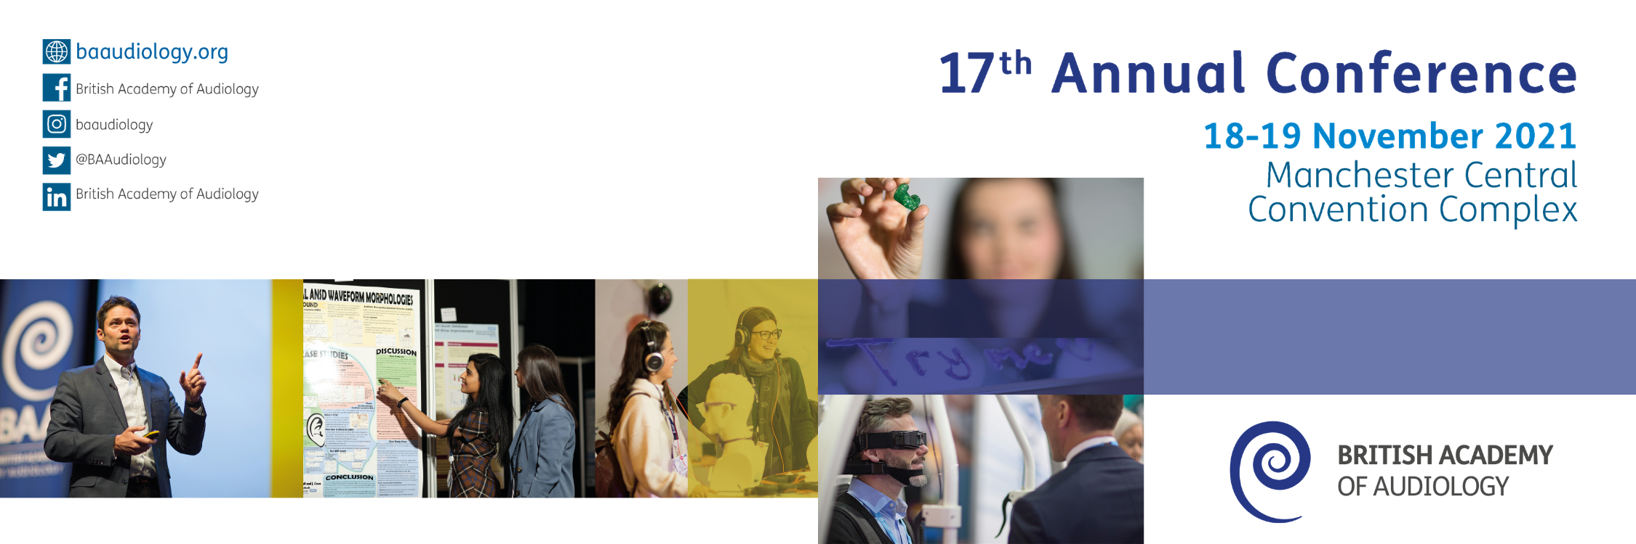
British Academy of Audiology
17th Annual Conference
18th & 19th November 2021, Manchester Central Convention Complex
Organised by the British Academy of Audiology, we are delighted to announce that the 17th annual conference and exhibition will take place on the 18th and 19th November 2021 at the Manchester Central Convention Complex.
Attracting over 500 delegates and 50 exhibitors along with an array of international speakers, BAA conference is the largest audiology conference in the UK.
Registration is now open! For more information visit: www.baaudiology.org/conference
The Programme:
The BAA Conference Programme team have worked hard in a short space of time to pull together a conference line up which we believe will provide two days of superb presentations and education that will have clinical impact. There will be updates from experts in research, overviews of policy updates, service innovations and examples of clinical progress which have taken huge technological leaps in the last 12 months.
As with every conference, we endeavour to ensure that you, our delegates, leave the event with a clear idea of how you can implement what you have heard in your own departments, practice, or career.
Key sessions this year will cover adult rehab, paediatric assessment, tinnitus and hyperacusis, learning disabilities, vestibular assessment and management, technology and health policy updates, neuroscience, service delivery changes, leadership, cochlear implants and careers support. We also have laughter on the agenda!
Once again, we bring you three parallel tracks, with a mix of Keynotes, invited speakers and free papers and a whole track of technology, product, and software updates. Following the success of the dementia clinic in 2019, this year we bring you a learning disabilities clinic where you will be able to review and see resources and ideas on display for your own clinic and speak to experts in the field.
Conference Highlights include:
- The Adrian Davis lecture to be presented by Professor Kevin Munro, Ewing Professor of Audiology, University of Manchester
- The Bamford lecture to be presented by Dr Paul Johns, Consultant Neuropathologist & Reader in Clinical Neuroanatomy, St George’s Hospital, London
- Other Keynote speakers include Dr Patricia Oakley, Professor James Warren and Professor Cynthia Casson Morton
- Parallel sessions looking at all aspects of Audiology across all sectors from research to clinical practice, encompassing commercial aspects
- Awards programme to acknowledge individuals and teams who have excelled in the Audiology profession
- Learning disabilities clinic
- The UK’s largest Audiology exhibition
- Exciting networking opportunities
- And much more!
To view the programme visit: www.baaudiology.org/conference
Abstracts:
Free paper and poster presentations form an integral part of the conference and are a fantastic way for those working within the audiology field to share best practice, research and network with colleagues.
Successful submissions will have their research displayed at conference or may be asked to present orally to Audiologists from the UK and beyond.
Submitting an abstract is an easy online process and we ask that all submissions are made before the closing date on Wednesday 21st July 2021.
Awards:
Every year at the BAA Annual Conference, we take the time to acknowledge those individuals and teams who have excelled, or shown exceptional commitment to the Audiology profession over the past year.
If you think someone deserves recognition, please take the time to nominate so we can all celebrate their achievements.
The closing date for nominations is Monday 23rd August 2021.

REGISTER NOW at www.baaudiology.org/conference
Early bird price valid until Friday 24th September 2021
For further information email events@baaudiology.org or phone 01506 292 045
Follow @BAAudiology and use #BAAConf on Twitter
Like us on Facebook https://www.facebook.com/baaudiology/
Instagram: baaudiology
LinkedIn: British Academy of Audiology

