Cochlear Implant Assessment

Information sheet for adults and their families
Courtesy of Oticon Medical. Image description: Photo of a young woman sat outside looking at her mobile phone smiling. She has a blue Cochlear Implant on her right ear. She has long brown hair.

About this factsheet

This factsheet is written for adults with a severe to profound hearing loss who are thinking of having a cochlear implant assessment. This factsheet only provides basic information about cochlear implants. Your local Cochlear Implant team can give you more information and discuss any other questions you have at your first assessment appointment.

Being referred for a cochlear implant assessment does not mean you will definitely be offered a cochlear implant. You will have to meet the national eligibility criteria and complete the rest of the assessment process before being offered a cochlear implant. You may also withdraw from the assessment at any time if you feel that having a cochlear implant is not the right choice for you for any reason. Your local Cochlear Implant team will support you to make the best choice for you, at the right time for you.

What is severe to profound deafness?
Most severe to profound deafness is due to damage to the tiny ‘hair cells’ in the cochlea that respond to sounds and send information about them along a hearing nerve to your brain. Hearing aids make sounds louder, but that does not always mean the damaged hair cells can pick up the sound.
Courtesy of MED-EL. Image description: a chart showing the pitch (frequency) and loudness of sounds (level) and how they relate to different levels of hearing loss. This chart is called an Audiogram.

What is a cochlear implant?

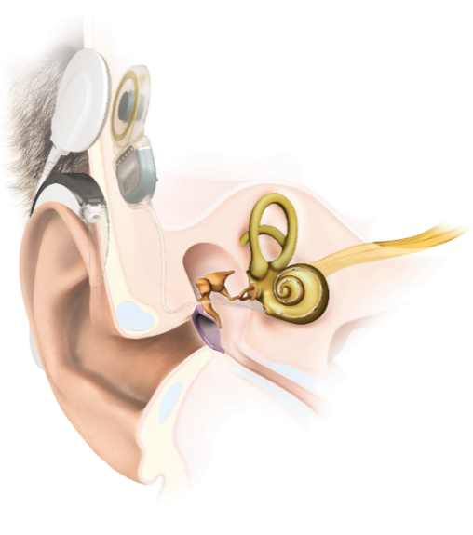
Cochlear implants give a sensation of hearing and may provide better hearing than hearing aids if you have severe to profound deafness and meet the national candidacy criteria. A cochlear implant is an electronic device with two parts: the internal ‘implant’ and the external ‘speech processor’. The system works completely differently to a hearing aid. It does not make sounds louder, but converts sound to electricity that travels along your
Courtesy of MED-EL. Image description: a drawing showing each part of the ear; outer, middle and inner. A Cochlear Implant is shown with the electrode inserted into the inner ear and the speech processor sitting on the outer ear.

hearing nerve and is recognized in your brain as sound.

The speech processor:
Courtesy of Oticon Medical. Image description: a photo of a speech processor showing it has 2 parts: a device that looks like a hearing aid sits behind the ear and a round smooth transmitter is placed behind and above the ear.

The external part looks like a hearing aid. It has microphones to pick up sounds around you. It passes these sounds to a tiny computer processor that converts them to electronic signals. The signals are then sent to the transmitter coil (circular part) placed flat against the skin slightly behind and above your ear. The coil sends the signal to the internal implant using a radio signal. The device uses batteries that you will need to change twice a week or recharge daily.

The implant:
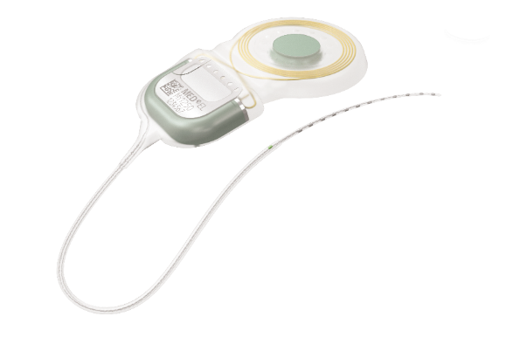
The implant part must be surgically implanted during an operation. It includes a receiver with a magnet in the middle, which sits just under the skin behind and above your ear, and a string of tiny electrodes placed gently inside the cochlea (inner ear). The magnet securely holds the external coil securely in place directly over the implanted receiver. The receiver picks up the signal from the transmitter coil on the outside of the skin and sends it to the electrodes inside the cochlea. The electrodes
Courtesy of MED-EL. Image description: A photo of the internal implant shows a tiny thin electrode that is placed inside the inner ear and a small magnet that sits under the skin.

take over the job of the damaged hair cells in the cochlea and send electrical signals along the nerve of hearing to your brain. Your brain learns to recognise these signals as sounds and speech with time and regular practice.

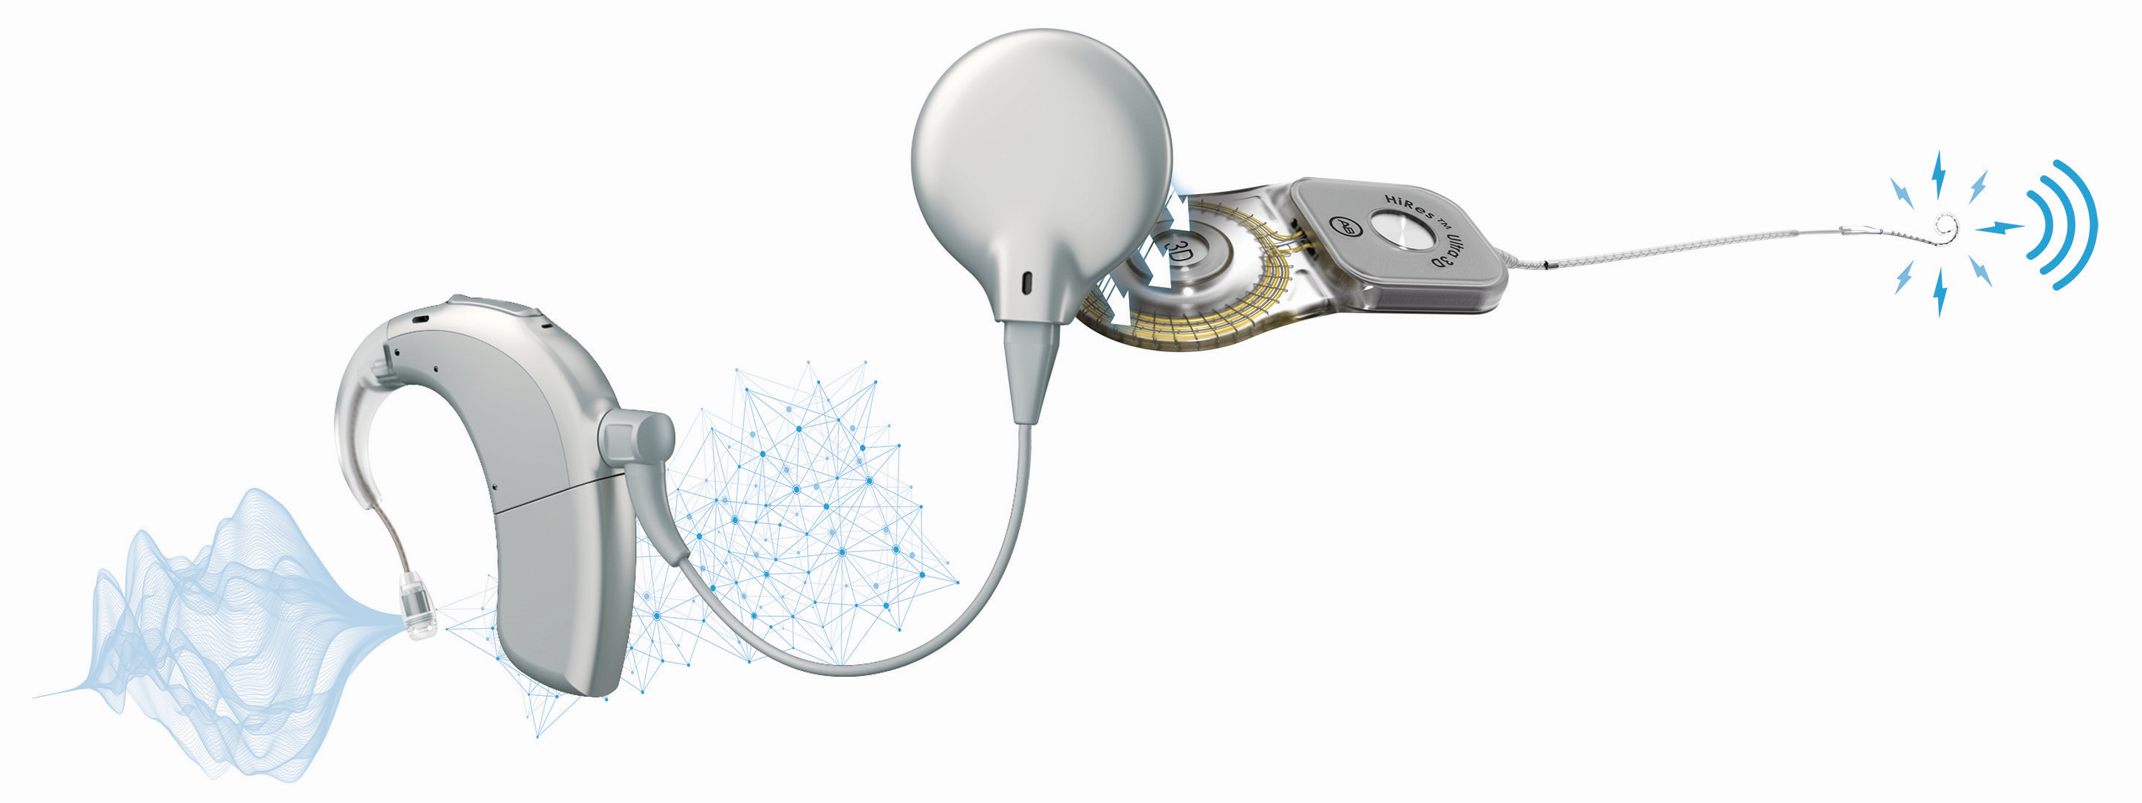
Microphones
Speech Processor
Magnetic Coil
Electrodes
Courtesy of Advanced Bionics. Image description: A diagram showing each part of a Cochlear Implant. The external device that sits on the ear has a microphone and speech processor, the round magnetic coil that attaches to the head, the internal magnet that is attached to the electrodes sitting in the inner ear.

You can easily take the external part of the Cochlear Implant off when you sleep, shower, or just want a break, just as you would with a hearing aid. A gentle pull will remove the coil from the magnet, so the whole speech processor comes off and can be stored in a case so it’s safe (the external devices are expensive). Many adults using implants have long hair, and it does not get in the way of using their implant.

Are cochlear implants suitable for all adults with deafness?
No. A cochlear implant may be suitable if you have a severe to profound sensorineural deafness in both ears, and you find that hearing aids do not help you very much. As a rough guide, if you cannot follow telephone conversations fluently using your
Courtesy of Cochlear Limited. Image description: a young boy sat on the floor with two adults. They are reading and talking.

hearing aid, then a cochlear implant assessment might be a good idea. For an implant to work, your hearing nerve must still function even though your cochlea is damaged. For some rare kinds of nerve deafness, a cochlear implant may not be suitable. Ears with lots of infections or mastoid cavities may need a two-stage operation.

Will a cochlear implant be right for me?
If you became deaf after developing spoken language skills, then a cochlear implant might be suitable. The Cochlear Implant team can advise you further based on your history. The better and the more recently you have had good hearing, the better the outcome with a cochlear implant will be.
Courtesy of Advanced Bionics. Image description: a young woman smiling. She has a dark brown Cochlear implant that matches her hair.

If you are an adult who has been profoundly deaf since a young age, a cochlear implant may not be the right option for you. This is because you need to have had some memory of sound to make sense of the signals provided by the implant. However, some adults born deaf or who became deaf at a young age can gain considerable benefit from a cochlear implant, provided they have had some benefit from hearing aids in recent years and communicate using speech and listening.

If you can hear well wearing modern high-powered hearing aids, with well-fitting earmoulds, then you may not get much extra benefit from a cochlear implant. The Cochlear Implant team will test how well you can hear speech without lip-reading, to see if you get enough benefit from your hearing aids.

You may benefit more from your implant if you receive a cochlear implant less than 10 years after becoming profoundly deaf. However, your age is not important when deciding whether an implant will be suitable for you. It is important that you are in good enough health to undergo an operation under general anaesthetic (although in some cases surgery under local anaesthetic is possible).

If you have an implant, you will need plenty of motivation and support from your family, friends, and hearing professionals, especially in the first few months as you learn to use it. You may need to attend the implant centre up to 9 times in the first year however the team will be flexible to your needs and some appointments may be done remotely if this suits.

Please note that as an adult, you will only receive one cochlear implant funded by the NHS unless you are deaf-blind, in which case you may have one in each ear. Children are allowed two implants under the NHS due to the importance of developing their speech and communication

What will a cochlear implant give me?
Courtesy of MED-EL. Image description: a man is at a train station asking for information. He has a black Cochlear Implant that matches his hair. He is using a Telecoil loop system to talk to the person sitting behind a glass screen.

This is a difficult question to answer, as no two people with a cochlear implant gain the same benefit. Benefit from a cochlear implant depends on many factors, including duration of your deafness, cause of deafness, and use of hearing aids, but it is still impossible to predict your benefit from these factors. The main reported benefits are:
- Relying less on lip-reading
- Gaining access to hear high-pitch sounds such as birds and alarms
- Ability to communicate more easily one to one

People that get the most benefit from a cochlear implant can follow a conversation on the phone or in background noise, and some can enjoy music, but this is not true for everyone with a cochlear implant. Most adults using a cochlear implant still have difficulties following a conversation in a noisy room, but this can improve with practice. Your local Cochlear Implant team will discuss your personal goals and likely benefit with you during your assessment.

How reliable are cochlear implants?
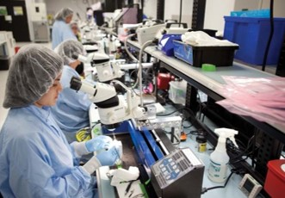
Courtesy of Advanced Bionics. Image description: adults working in a laboratory testing Cochlear Implant components. They are wearing gloves, a hair net and a uniform. They have microscopes and lots of other medical testing equipment around them.

Cochlear implants are reliable devices. The chance of the surgically implanted part of the implant failing is very low (generally less than 1% within the first ten years),

and many implant users have been using their implants for over 30 years without any problems. If it did fail in the future, the implant can be replaced through another operation, and the outcome tends to be like the first operation. The external speech processor that sits behind your ear can be replaced easily if any faults develop, but with some basic maintenance, they are also reliable.

Will having a cochlear implant stop me doing anything?
Courtesy of Oticon Medical. Image description: A girl with wet hair is sat in a swimming pool while wearing her Cochlear Implant.

Having a cochlear implant should not restrict daily activities for most people. Taking part in most sports is fine, but you may be advised to avoid certain high-risk contact sports where impact to the implant is possible (e.g. boxing), and participation in extreme sports such as skydiving should be avoided due to the risk of damaging the implant. You can swim as normal, and SCUBA diving may be allowed to a specific depth dependent on manufacturer. Travelling in an aeroplane is also fine. You will need to inform your doctor if you need an MRI scan, as the implant is metal and contains a magnet, and correct precautions need to be taken. If you have specific concerns, you can discuss these with the Cochlear Implant team during your assessment.

What can I expect from the assessment?

If you decide to have a cochlear implant assessment, your audiologist will refer you to your local Cochlear Implant team, and you will receive an appointment to attend. Please bring a relative or friend along if you wish, unless specific restrictions are in place, e.g. during COVID-19.
Assessment for a cochlear implant consists of a few stages (described below). The process from first assessment to implantation cannot be predicted, it depends on individual and local factors and could range from 4-18 months. During your assessment, you will be given information about what to expect from a cochlear implant. You will receive a lot of information to help you make an informed decision about whether you feel a cochlear implant is right for you.

Courtesy of Oticon Medical. Image description: three people are sat around a table talking in an Audiology office. A man with short grey hair is wearing a silver Cochlear Implant, he is holding a hearing aid. There is a computer screen showing different types and colours of Cochlear Implant.

Initial assessment appointment
At the initial appointment, you will see an audiologist who will ask you questions regarding your deafness, medical history, hearing aids, lifestyle, motivation and

listening goals. They will then do some tests, including a hearing test and speech tests, to determine if you may be entitled to an NHS-funded cochlear implant. At the end of the appointment, they will let you know whether you meet the cochlear implant criteria or if you require further investigations. If you meet the criteria, they will discuss the next steps with you if you wish to proceed with the rest of the assessment process. If you don’t meet the criteria, they will discuss the reasons for it and provide advice on future management (review later, consider different hearing aids, etc.)

The next steps of the assessment include:

Rehabilitation assessment
During this appointment, you will discuss the process of learning to hear with a cochlear implant (this is called hearing rehabilitation). This can be quite hard at the beginning, so we need to make sure that you and your family are prepared for this. You may be given some questionnaires about your deafness and what you can expect from a cochlear implant to ensure your expectations are realistic, and your personal goals and reasons for having a cochlear implant will be discussed. If you have any worries or concerns, you are welcome to share them at this or any other appointment.

Meeting someone with a Cochlear Implant
If you are considering a cochlear implant, we feel it is important to meet someone who has had a cochlear implant. They can tell you about their experiences from a different perspective to hearing professionals. Bear in mind that every cochlear implant recipient’s history is unique, and their experiences may differ to yours. You may want to attend a local User Group, where you can meet various people with implants. If you prefer, the Cochlear Implant team can put you in one-on-one contact with another person with a similar history of deafness.

Head scans
A CT scan and (usually) an MRI scan are done to show the surgeon a full view of your inner ear bones and fluids. This helps them plan your surgery, and may help to decide which ear would be better to implant.

Risks counselling
The cochlear implant team will go through the surgical process and risks in more detail. Cochlear implant surgery is an established operation which is generally very safe. Most people will experience no major problems following this operation but as with every surgical procedure, there are some risks, and these will be outlined to you at this appointment.

Medical assessment
Cochlear implant surgery usually requires a general anaesthetic, so you will have an assessment of your medical suitability for surgery. This will be done by a specialist ‘pre-op’ nurse. They will also decide if you are suitable for ‘day-case’ surgery or if you will need to stay overnight after your operation. It is recommended that you ask a family member or friend to spend the first night at home with you.

Cochlear Implant Clinic and Consent
During this appointment you will meet one of the cochlear implant surgeons. Usually this takes place at the end of your assessments once you are ready to consent for a cochlear implant. If you have more complex ear problems, like ear infections, you may be seen in clinic earlier. The surgeon will check your ears and medical history with you. You may sign a surgical consent form and be added to the surgery waiting list. If
you have never had a ‘pneumococcal’ vaccination, then you will be offered this to reduce the risk of infection after the operation.

Your decision

Deciding to attend a cochlear implant assessment may not be an easy decision, and you may need to learn more about it before feeling confident about what you want to do. A referral does not mean you have committed to having a cochlear implant. If you are offered an implant, the final decision is yours, and you can change your mind at any time.
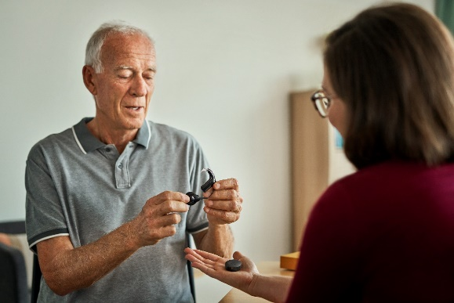
You may also decide to wait a little longer before making your decision. The Cochlear Implant team aims to provide you with all the information you need to make the right decision for you, at the right time for you.
Courtesy of Cochlear Limited. Image description: A man is holding a brown Cochlear Implant in his hand. He is talking to a lady and looking at the Implant.

Please note that to be eligible for an NHS-funded cochlear implant you have to meet certain eligibility criteria, as set by the National Institute for Health and Care Excellence (NICE), last reviewed in 2019 (https://www.nice.org.uk/guidance/TA566)

Common myths about Cochlear Implants:
‘’It’s brain surgery’’
Cochlear implant is ear surgery, not brain surgery - an internal implant is placed under the skin behind the ear, and an electrode is placed into the inner ear (cochlea). No part of the brain is touched.

‘’If you go through the assessment period, you must get it’’
The assessment process is an opportunity to decide if an implant is right for you. You can change your mind at any time.

‘’Normal hearing is immediate’’
When waking up from surgery, you will not be able to hear from the implanted ear, as the ear needs time to heal. The cochlear implant will be activated between 2-4 weeks after surgery, depending on your healing process.

‘’Restores your hearing back to normal’’

A cochlear implant is not a natural device that replaces your ear. It’s a medical device that helps you hear. It is surgically implanted to bypass the outer and middle ears to stimulate the hearing nerve directly

‘’Cochlear Implants are only for children or babies’’
A cochlear implant is suitable for all ages. Adults in their 90s can benefit from this technology.

“You cannot have MRI scans’’
Advances in technology have enabled MRIs to be done with most cochlear implants, following special precautions. Each manufacturer has different levels of MRI tolerance, and some implants have the option to remove or replace the magnet.

‘’Everyone with hearing loss should get one’’
Not all deaf people will want or need a Cochlear Implant. It’s important to consider your own personal goals and find out if a Cochlear Implant could help you access sounds you are struggling to hear.

Courtesy of Cochlear Limited. Image description: An older lady is talking to a young child who is sat on another lady’s knee. The lady has a pale-yellow Cochlear Implant that matches her blonde hair. They are smiling and laughing.

Sources of further information
There is a lot of excellent information online for potential cochlear implant recipients. We suggest the following trusted websites should you require further information:

- British Cochlear Implant Group (BCIG): https://www.bcig.org.uk/

- Hear Together https://www.heartogether.org.uk/hearing-technology/cochlear-implants

- National Cochlear Implant Users Association: https://www.nciua.org.uk/

- Cochlear Implant Manufacturers:

- Advanced bionics: https://advancedbionics.com/uk/en/home.html

- Cochlear: https://www.cochlear.com/uk/en/home

- MED-EL: https://www.medel.com/en-gb

- Oticon Medical: https://www.oticonmedical.com/uk/cochlear-implants

