Cadmus Inclusive
Thinking differently for a brighter tomorrow…
The Booklist
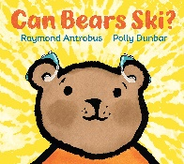
Can Bears Ski? – By Raymond Antrobus
Little Bear feels the world around him. He feels his bed rumble when Dad Bear wakes him up in the morning. But something else is missing, like when his friends tell jokes that he isn't sure he understands. Little Bear hears the question, "Can bears ski?" Then, one day, Dad Bear takes him to see an "aud-i-olo-gist," and Little Bear learns that he has been experiencing deafness and will start wearing hearing aids. Soon he figures out what that puzzling refrain is: "Can you hear me?"

Echo Come Home - By Megan Rix
Eleven-year-old Jake is dreading his new school. No one understands how hard it is for him to make friends. But then Jake meets Echo. Echo is a stray puppy, training to be a hearing dog. With Echo by his side, Jake's confidence grows. But then something terrible happens and Jake and Echo are separated. Determined to find his way back to Jake, Echo sets out on the difficult journey home.
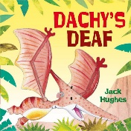
Dachy’s Deaf – By Jack Hughes
Dachy wears a hearing aid. But sometimes, when his friends get too noisy, he likes to turn it off to get some peace and quiet. One day, when his hearing aid is off, Dachy falls asleep and ends up floating down the river towards a waterfall and a hungry crocodile. Can his friends rescue him in time?
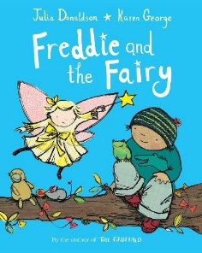
Freddie and the Fairy – By Julia Donaldson
Freddie is desperate for a pet, so when he rescues Bessie-Belle and she offers to grant his wishes he knows just what to ask for. The only problem is that Bessie-Belle can't hear very well, and Freddie tends to mumble. Whatever can they do? Luckily the Fairy Queen is on hand to explain . . .
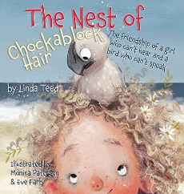
The Nest of Chockablock Hair: The friendship of a girl who can’t hear and a bird who can’t speak – By Linda Teed
Maria is used to playing by herself. She's deaf, and other kids have trouble communicating with her. But when Louie, a lost baby albatross, lands in Maria's wind-blown hair, she discovers that spoken words are not the only way to communicate. Can they work together to find Louie's family? Will Louie give Maria the confidence she needs to make new friends?
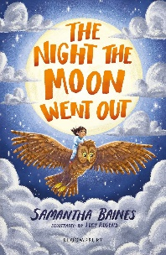
The Night the Moon Went Out – By Samantha Baines
Aneira is a hearing-aid wearer and she is super scared of the dark. When the moon suddenly goes out one night, Aneira is on a mission to turn it back on! With the help of her owl friend, she sets off on a journey to fix the moon and overcome her fear.

Ranvir Cannot Hear – By Genevieve Yusuf and Shermain Philip
Ranvir the elephant goes on a journey over the plains of India in search of his hearing and meets some great friends along the way. They tell him how even when you can’t do what’s expected of you, there may be something else that you can do.

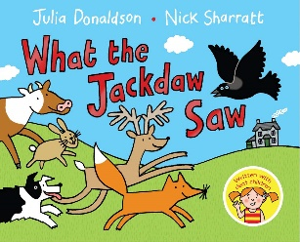
What the Jackdaw Saw – By Julia Donaldson
An enthusiastic jackdaw is desperate to tell everyone about his birthday party. When he flies overhead inviting all the animals to come, they're silent; tapping their foreheads instead. It's not until the jackdaw finds himself flying towards grave danger that he realises the deaf animals were actually trying to warn him with sign language.
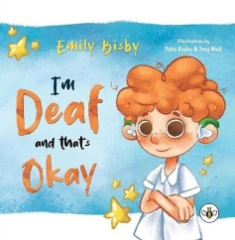
I’m Deaf and That’s Okay – By Emily Bisby
Timmy is starting year two, he is worried that his classmates aren't going to like him because he's deaf. Follow Timmy's journey as he finally gets to say, "I'm deaf and that's okay!"
Dad and Me in the Morning – By Patricia Lakin
Full-color watercolor paintings illustrate the story of a young deaf boy and the special relationships he enjoys with his father and baby brother.

Other sources for book suggestions:
https://www.ndcs.org.uk/information-and-support/parenting-and-family-life/families-magazine/reviews/books/
https://kidadl.com/home/childrens-book-deaf-characters
https://www.harpercollins.com/blogs/harperkids/childrens-books-deaf-characters
https://www.booktrust.org.uk/booklists/d/deaf-awareness-week/
https://www.fcps.edu/sites/default/files/media/forms/PictureBooksWithDeafCharacters.pdf

