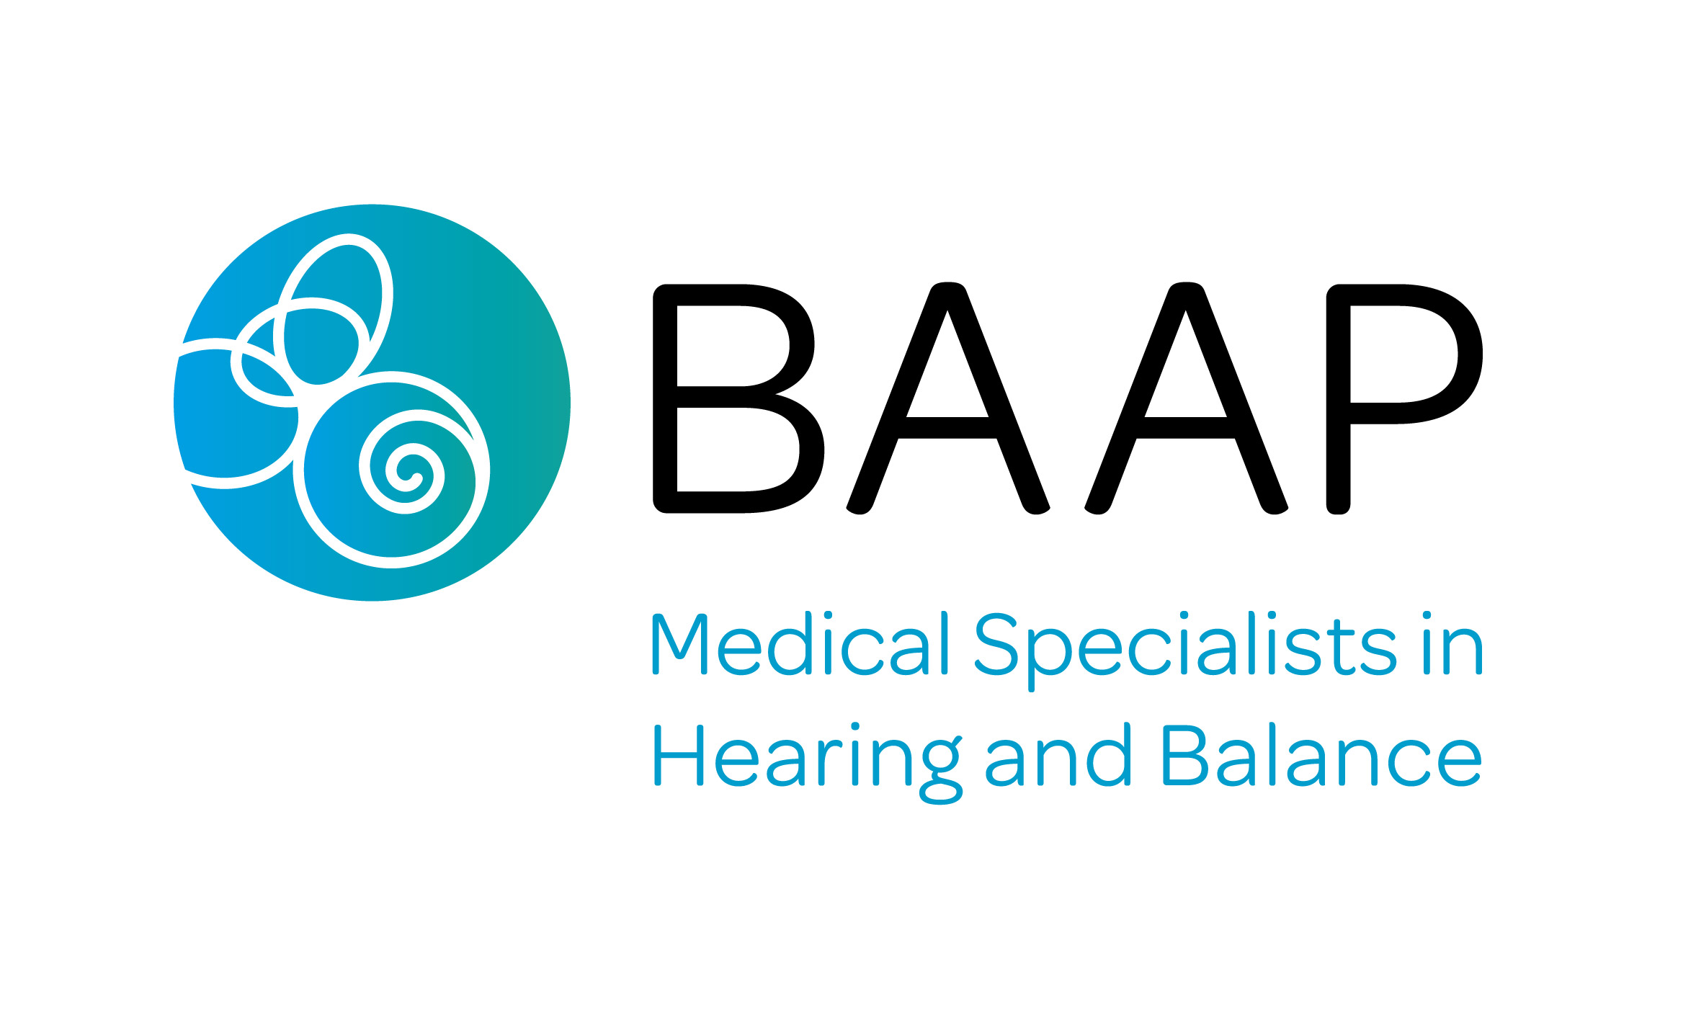

The British Association of
Audiovestibular Physicians

BAAP Hallpike Prize - 2022

The Hallpike prize was first awarded by the British Association of Audiovestibular Physicians in 2009, following the kind donation of Dr Jeremy Hallpike, Emeritus Neurologist from Adelaide, Australia, in honour of his father Charles Skinner Hallpike, a key figure in the early days of the development of Audiovestibular Medicine as a specialty.

The prize is awarded annually for the best project of the past 24 month period (research, audit or review of subject) in the area of Audiovestibular Medicine. The project can be unpublished, published or be in form of a presentation or poster, but the prize committee must be able to assess its quality from the available information. This committee consists of the Chairs of the Education, Audit and Clinical Standards BAAP Subcommittees under the chairpersonship of the Vice President of BAAP.
The successful candidate receives the prize certificate and a cheque for £300 which will be awarded at the March 2023 BAAP Annual Conference (or in exceptional circumstances at the October 2023 Hallpike Symposium) when the prize winner is expected to present his/her work.
The criteria on which the selection is based are:
- Quality of project (50%)
- Relevance to Audiovestibular Medicine (20%)
- Relevance to clinical practice (10%)
- Applicant’s history of research experience (20%) (the less experience, the better rating to encourage inexperienced applicants)

Rules for candidates submitting applications for Hallpike Prize:
Documents must be in MS-Word *.doc or *.pdf format, using Arial font 10, using the form at the end of this guide. The application needs to contain:
- The applicants name, address, contact details and designation at completion of project are required as well as the institution at which the project was undertaken.
- A clear declaration which part of the project is work of the candidate and which part that of others
- Outline of reasons for undertaking the research, methods and analysis of the project, and how conclusions were derived highlighting any problematic areas (500-700 words) [please state if work is published, submitted or otherwise openly available]
- Relevance of the project to Audiovestibular Medicine in the UK (150-250 words)
- Clinical applicability (max 150 words)
- Candidates experience in audit and research ( max 150 words)
- Candidates brief CV (2 A4 pages maximum)

The completed form should be emailed to the Honorary Secretary of BAAP – honsec@baap.org.uk. It should be received by the BAAP Honorary Secretary before 5 PM of Friday 6th January 2023. Those received later will be considered for the following year.

BAAP Hallpike Prize Application Form - 2022

Name, Title:
Address of institution at which project performed: (incl. Tel., Email)
Address for correspondence (if different from above): (incl. Tel., Email)
Applicants designation at institution above:
Declaration of applicant: which part of project were performed by applicant and which contributed by others:
Project (500-700 words total):
Reasons / Context for undertaking the project:
Methods:
Analysis:
Conclusions and how they were reached:
Is the work published, submitted or otherwise accessible to others?

State the project relevance to Audiovestibular Medicine (150-200 words):
State the clinical relevance of the project (100±50 words)
Applicants previous experience in audit / research (100±50 words)

Attach a brief CV (2 A4 pages maximum)
*I confirm that I will be available to present the project during the BAAP 2022 Annual Conference (16TH -17th March 2023).
*I will contact BAAP to make alternative arrangements. (Please delete as appropriate)

Signed

