**Cadmus Inclusive**

***Thinking differently for a brighter tomorrow…***

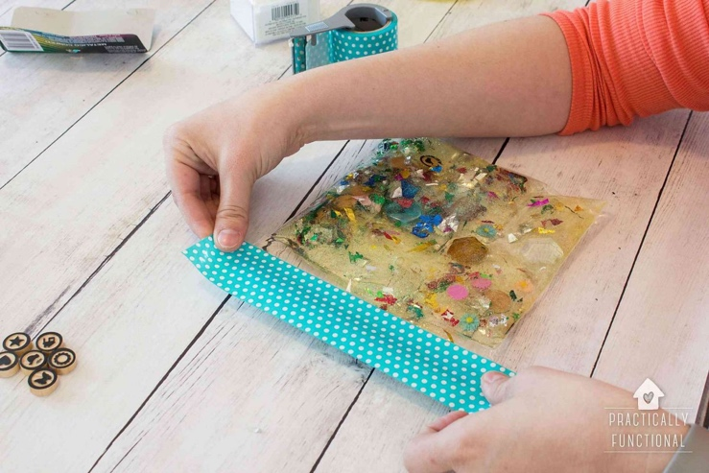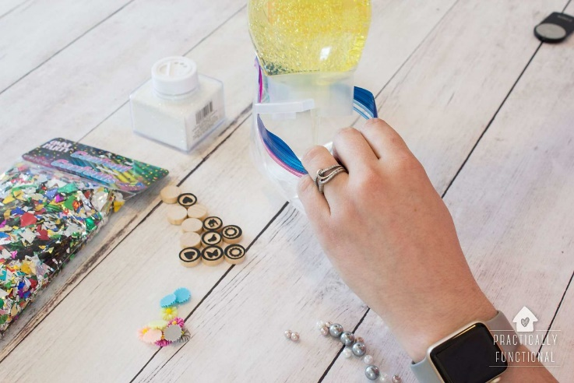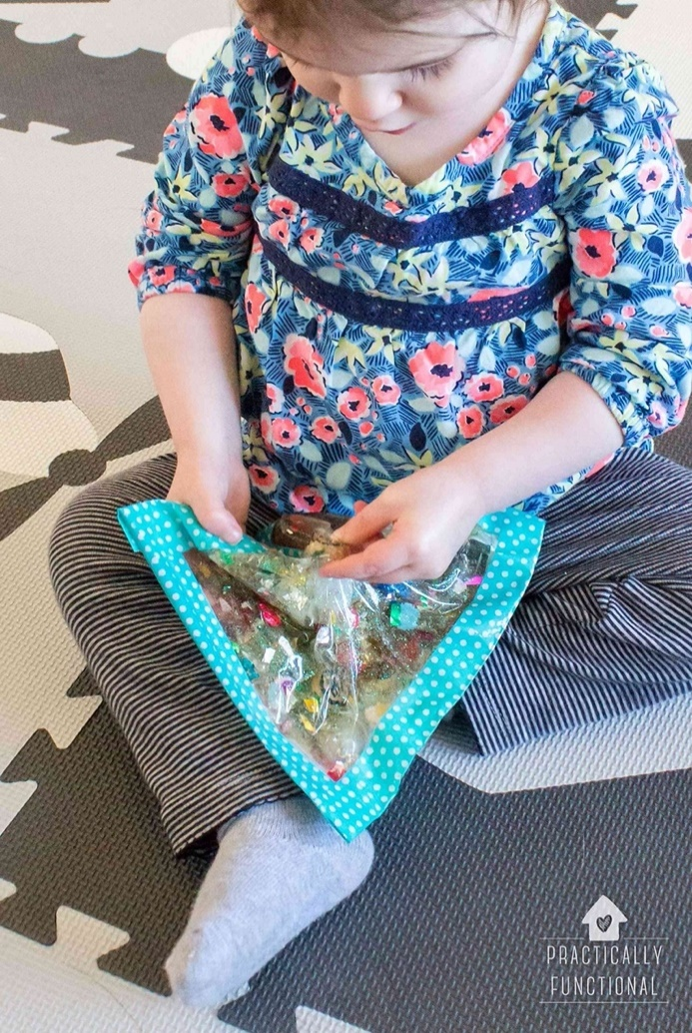**How to make a sensory bag**

1. Fill your plastic bag with hair gel or conditioner, leave a little space for the gel to move around when squeezed.
2. Bring your sensory bag with you to show the who you will be meeting! You can use this in your appointment to help you feel calm if you want to.
3. Add in small crafty bits such as pompoms, sequins or beads. Seal the bag tightly and use a strong tape to secure all the edges.