

**Cadmus Inclusive**

**Bear’s Treasure Hunt**

**Welcome to Audiology! I have a special job for you. Can you find the matching pictures of some of the equipment we have in the clinic? I’ve hidden them all around the waiting room. Good luck!**

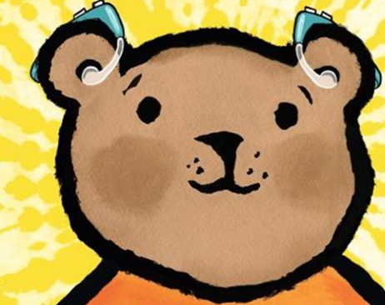

|  |  |  |
| --- | --- | --- |
| **Equipment** | **Its Name** | **Found it!** |
|  | **Tympanometer** |  |
|  | **Audiometer** |  |
|  | **Response Button** |  |
|  | **Otoscope** |  |
|  | **Bone Conductor** |  |
|  | **Audiometer Headphones** |  |