Cadmus Inclusive
Thinking differently for a brighter tomorrow…
How to Make a Worry Buster
A Worry Buster is a fun game that can help you to think about something else if you get a worry.
 | Step One: Take a square piece of paper.
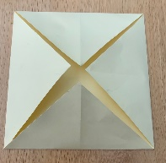 | Step Two: Fold the corners of the paper into the middle so that all of the points touch. This is the four section side.
 | Step Three: Turn your paper over and repeat step two. This is the eight section side.
 | Step Four: Turn your paper over and push up the corners so that you can fit your index finger and thumb from both hands in each pocket underneath.
 | Step Five: Flatten your creation back down. Decorate the four section side with the numbers one to four.

 | Step Six: Decorate the inside (eight sections) with your favourite shapes.
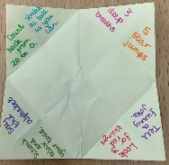 | Step Seven: Open up each section and write a distraction activity such as: take three deep breaths, do 5 star jumps, tell a funny joke, find three red things …
 | Step Eight: Fold your Worry Buster back up. It is now ready to use!
How to use your Worry Buster. | If you are feeling worried at any point before or during your appointment you can use your Worry Buster to distract you. First of all, move the points backwards and forwards using your index fingers and thumbs for the number you have chosen from the outside. Look inside and choose a shape. Spell out the shape name moving your Worry Buster on each letter. Look inside again and choose another shape. Open up the flap of your chosen shape and perform the activity.

