Hello CI Champions,

Hope you’re all well and enjoying your first newsletter! Read on for a few updates and reminders from Advanced Bionics. The Support & Community Team is here for you so if you need any support, don’t hesitate to contact us at hear-uk@advancedbionics.com.

One to One Support Sessions for Candidates and their Families
Virtual Consultations with our Support & Community Specialists can now be booked through our NEW online booking system! Just share this link and an appointment can be made at a convenient time in just a few clicks: https://bit.ly/3SKsjTi

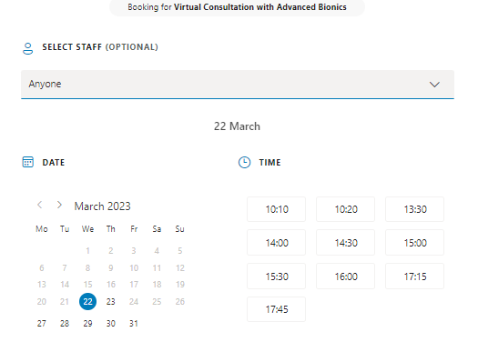

Look out for new downloadable flyers that you can share with your candidates and families on the CI peeps webpage coming soon! https://www.advancedbionics.com/gb/en/campaign/ci-peeps.html

Journal Club
Our next journal club will explore best practice for bimodal fittings – a topic that a number of you have expressed an interest in recently. A link to access the paper and guidance for review will be sent to you after you’ve registered.
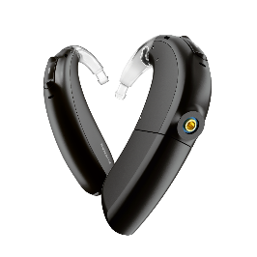
Date: Wed 24th May 2023
Time: 12.30 – 1.15pm
Location: Zoom
Registration link: https://bit.ly/3FkVaYL

NEW Severe and Profound (SAP) Network for Hearing Healthcare Professionals (HHCPs)
We believe Cochlear Implants should be part of a person’s hearing care continuum. To support you with this we are developing a new SAP Network for HHCPs. To learn more about this new initiative, please email hear-uk@advancedbionics.com.
